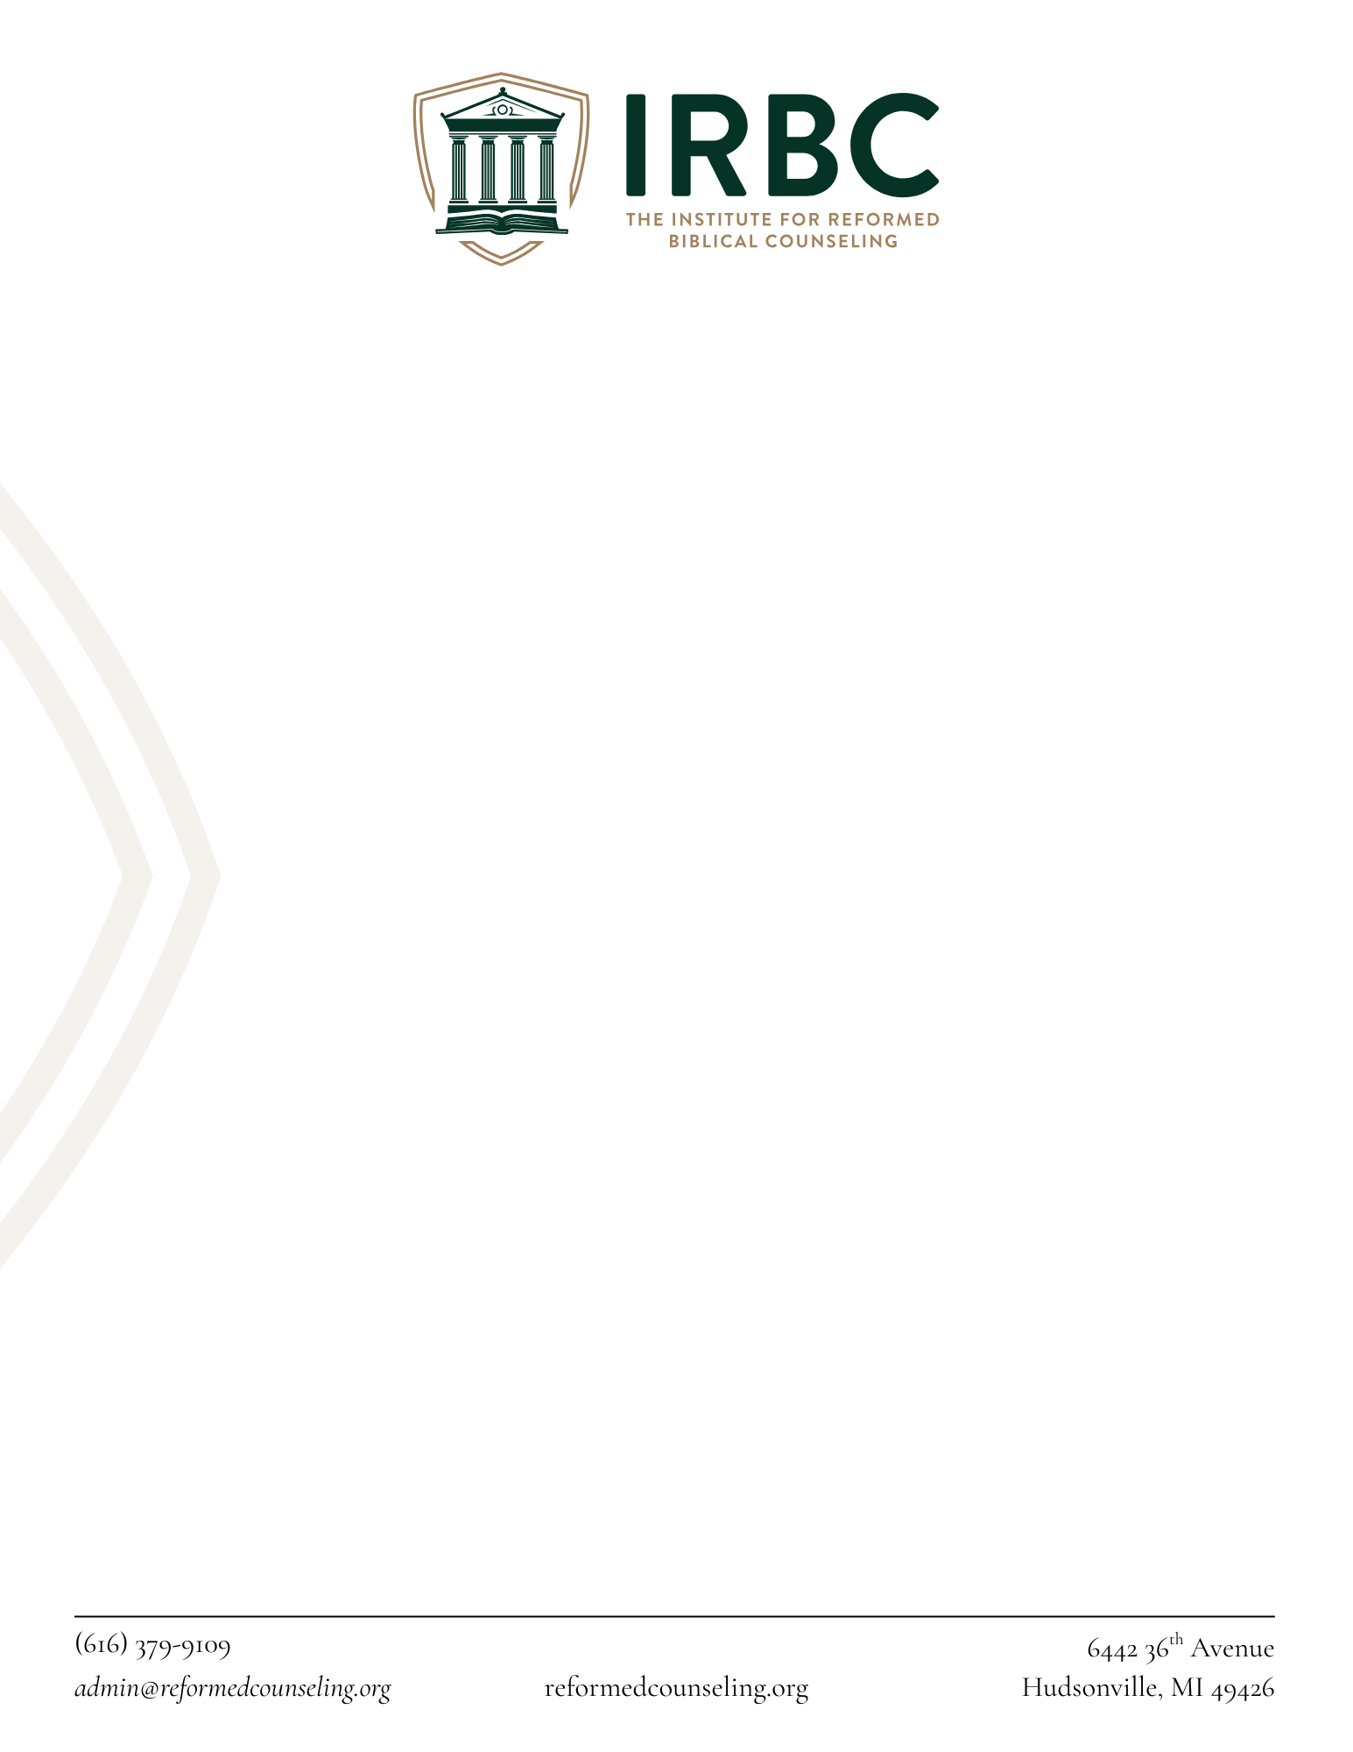
Dear Pastors and Elders,
The Institute for Reformed Biblical Counseling (IRBC) sends you greetings in the Lord Jesus Christ!
Your church member, _______________, has applied to begin the biblical counseling certification process with IRBC. We at IRBC deeply value the oversight of the local church in discipleship and shepherding of those engaged in biblical counseling, and as a confessional institution we require certain theological truths upon which our ministry is grounded to be affirmed by our counselors and their local church.
All IRBC certified counselor are expected to be members of churches that hold to one of the three Reformed confessional Standards: The Westminster Confession of Faith, the Three Forms of Unity, and the Second London Baptist Confession of Faith (1689). For Baptist churches that do hold to Reformed doctrine but hold to a different doctrinal statement, we respectfully ask that your church affirm the following in order to support the applicant’s certification with IRBC:
- That you believe and recognize the Second London Baptist Confession of Faith (1689) to be a faithful and accurate summary of the essential truths taught in Holy Scripture.
- That you acknowledge and affirm your church’s authority and responsibility over the applicant as a member and as one engaged in biblical counseling ministry.
- That you are willing to exercise oversight of the applicant’s counseling ministry in a manner consistent with the doctrinal convictions represented in the Second London Baptist Confession of Faith (1689).
- That you agree to notify IRBC should there be any significant change in the applicant’s or the church’s doctrinal commitments that would affect your fitness to supervise the applicant as an IRBC certified counselor.
If you can affirm these four items, please sign below and return to IRBC.

_______________________________ _______________________________
Pastor/Elder Applicant
_____________________________________ _____________________________________
Date Date

